**CSA0562- DBMS**

- B. Rishitha

192324130

# SQL PROGRAMMING PROJECT LOGICAL MODEL:

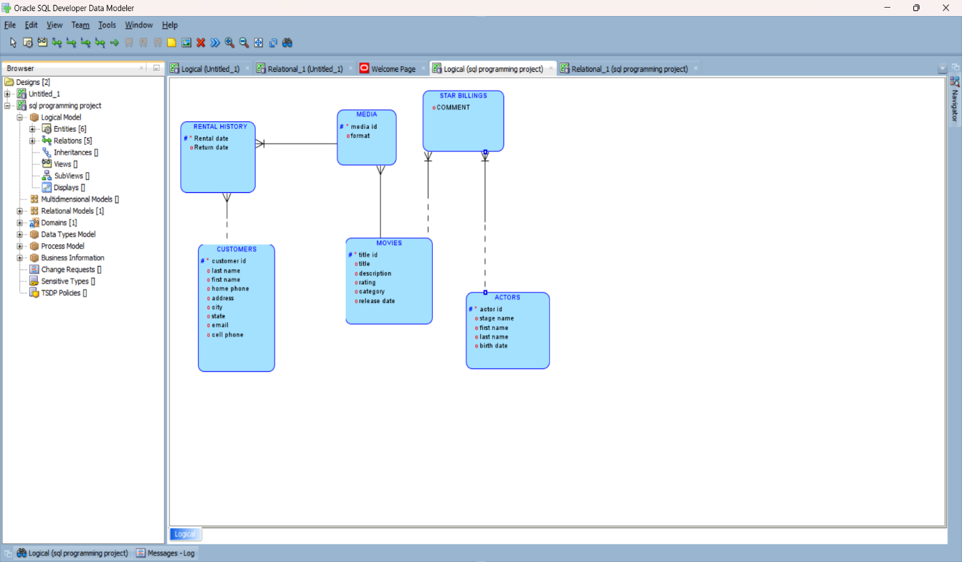

# RELATIONAL MODEL:

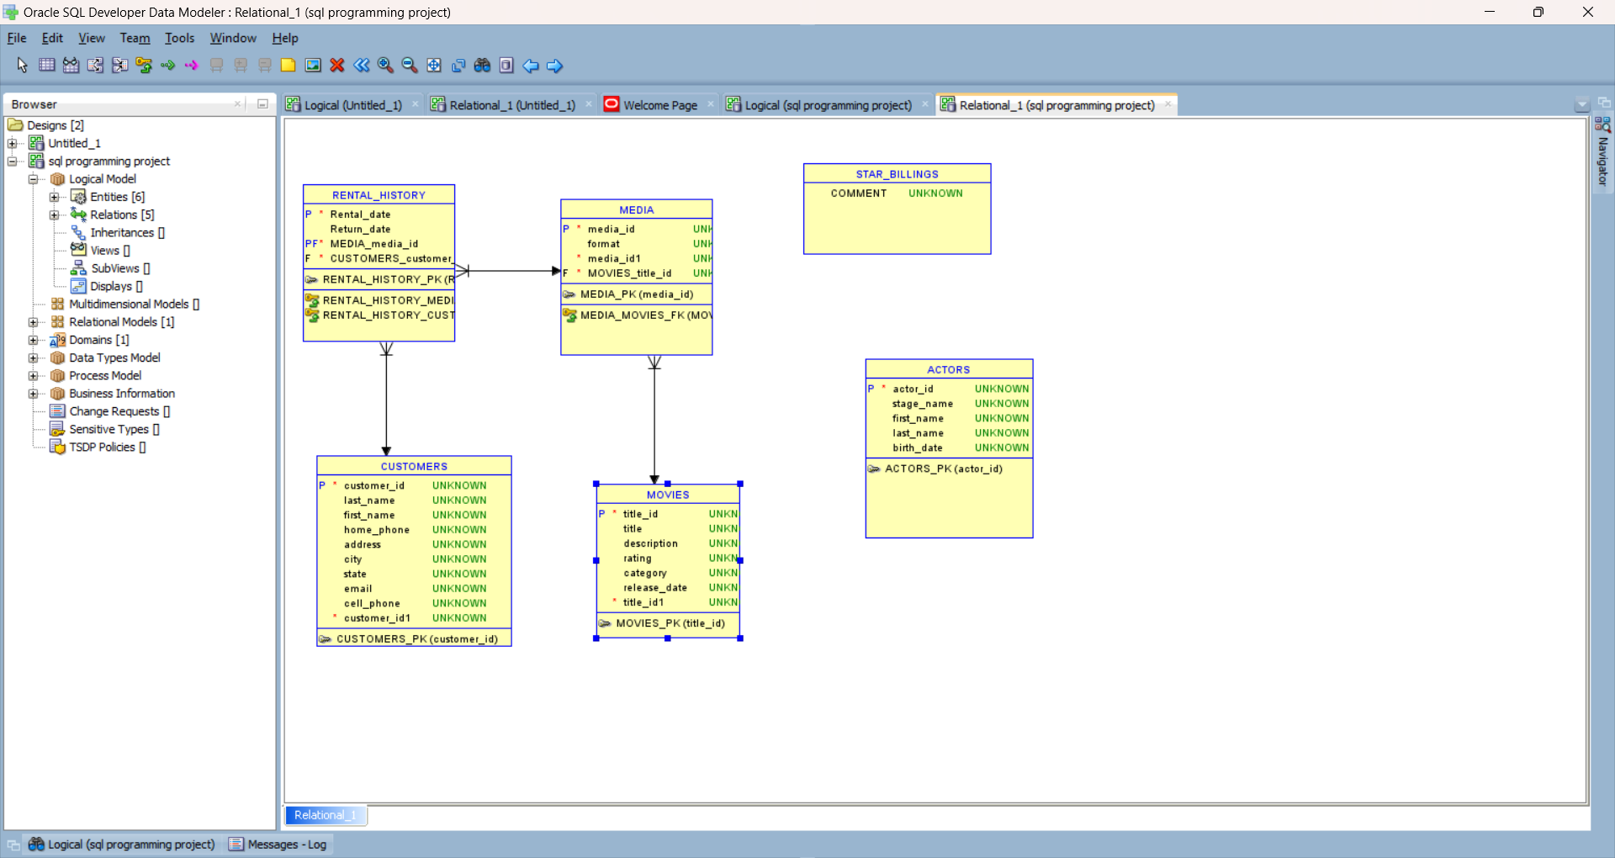

DDL QUERY:

